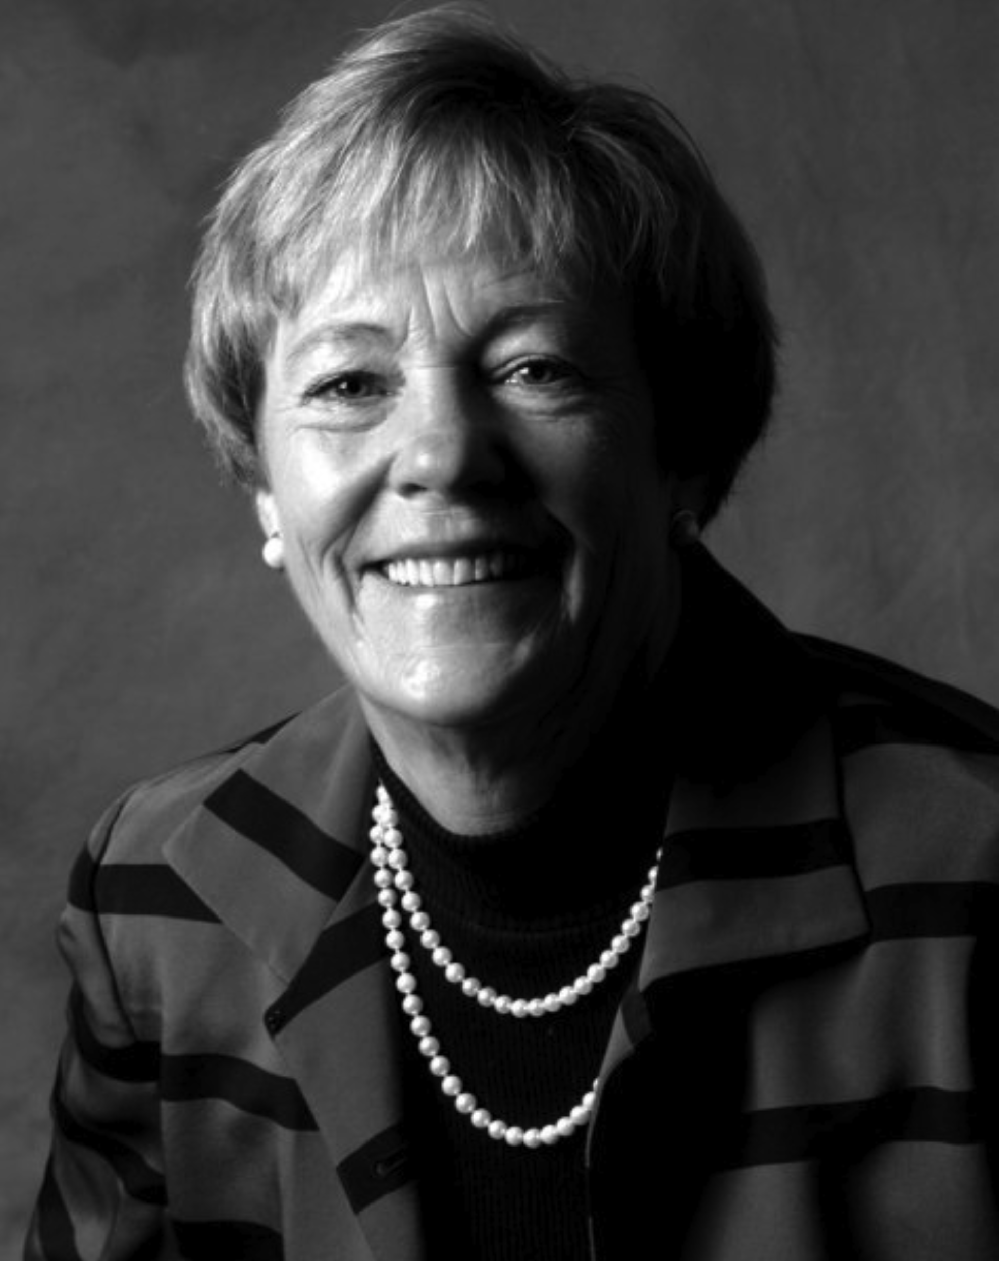 | Sharon Chamberlain Consulting  Madison, Wisconsin  608-695-3024 cell  sharonrchamberlain@gmail.com  www.linkedin.com/in/sharonrchamberlain

MARKET RESEARCHER / Business & Community Trail blazer

Executive and Community Leader known as the “Market Research Guru” in the region. Leader, Mentor and Coach successful in finding win-win solutions for complex problems. A trail blazer, bringing together diverse groups to tackle important issues. Excels as a focus group moderator with gifted ability to engage people in sharing their deep emotions.
Praised for helping companies make data driven decisions. Through Market Research, saved or generated millions of dollars annually for clients. Applauded by her staff for being inspiring, motivating and “the best boss ever.”

Market Research
- Internal full-time or part-time: Consumer Insights Advisor (Market research, data gathering, analysis, recommendations), Project Director, Liaison
- Consultant on wide variety of initiatives, community support efforts, capital or development campaigns, feasibility studies, customer satisfaction, new product development
OR

Interim Leadership
- Leader for an organization, company or department
- Coaching & mentoring employees
- Change leadership – assessing and leading needed culture change, merging entities, rebranding
BACKGROUND & CLIENTS
CLIENTS SERVED:
Fortune 100-500 companies…Community organizations of all sizes…Manufacturers…Healthcare …Colleges and universities Banks & other financial institutions…Insurance companies…Real Estate developers
EXPERIENCE:
Chamberlain Research Consultants, Inc. – President & CEO
Wisconsin Gas Company – Director of Consumer Affairs & Market Research
Citizens Utility Board – Executive Director
Accomplishments - BUSINESS
- Determined feasibility of nursing home, senior campus, quarry reclamation, and multipurpose developments
- Researched attributes to help Caterpillar develop its first truck; helped Honda select “Element” as name for off-road car
- Helped banks such as Wachovia and TD Bank North improve customer service, increase merger success, improve brand awareness and select product offerings
- Recommended strategy to sell renovated UW Camp Randall Stadium: resulted in complete sellout in one month
- Guided trade associations to through major changes or legislative wins. Included: Wisconsin Dental Association, WEAC, Wisconsin Realtors Association
- For AprilAire, found right pricing structure to make sure client didn’t leave money on the table
Accomplishments - COMMUNITY
- Conducted research that ensured passage of Referendum for Monona Terrace
- Developed strategy for two successful capital campaigns for Agrace HospiceCare
- Through research recommended successful rebranding and name change to Agrace
- Determined economic impact of Art Fair on The Square
- Advised Madison Symphony Orchestra on adding a Friday night performance which resulted in sell out
Boards
UW Athletics-Director | Agrace-Executive Committee
International Breast Cancer Research-Treasurer | Tempo-Past President

